PEBA 6631 – Tax Exemption Batch, tax instructions not being created

SID: 274371

Updated TD1 claim amounts (for Saskatchewan and federal):

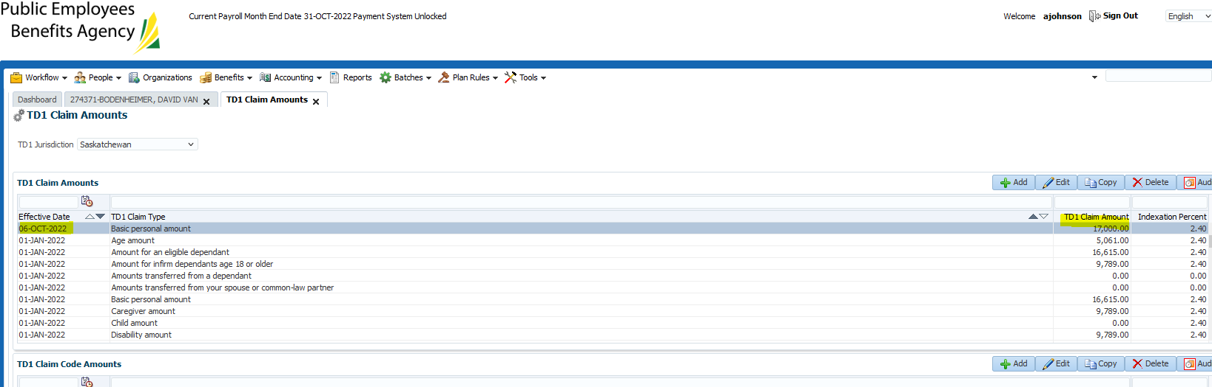

Ran Tax Exemption Indexation Batch:

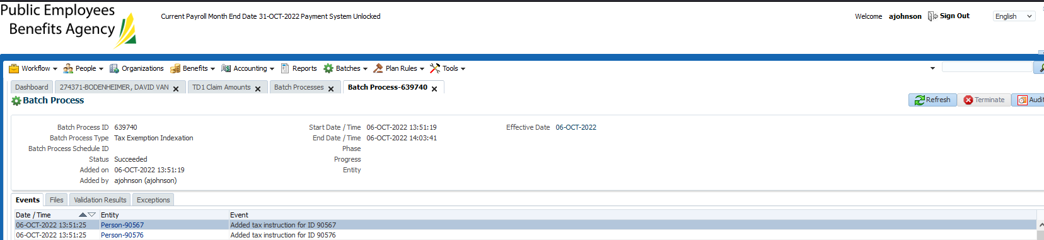

No tax instruction generated for member with effective date of Oct 6, 2022 as expected:

